Scottish Country Dancing  Takes place here  every  ??????????  Interested ?  Contact us at  Info @ ????????????? | 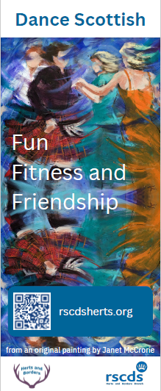
Scottish Country Dancing

Taking place here Now!

Interested ?

Come in and talk to us

